2.3 Guided Practice: Install and Integrate Mongoose into MEAN

Christopher Crayton
ECPI University
SDC360: Web Application Development
Mohammad Zakaria
March 15, 2026

2.3 Guided Practice: Install and Integrate Mongoose into MEAN
1. Initial code running:
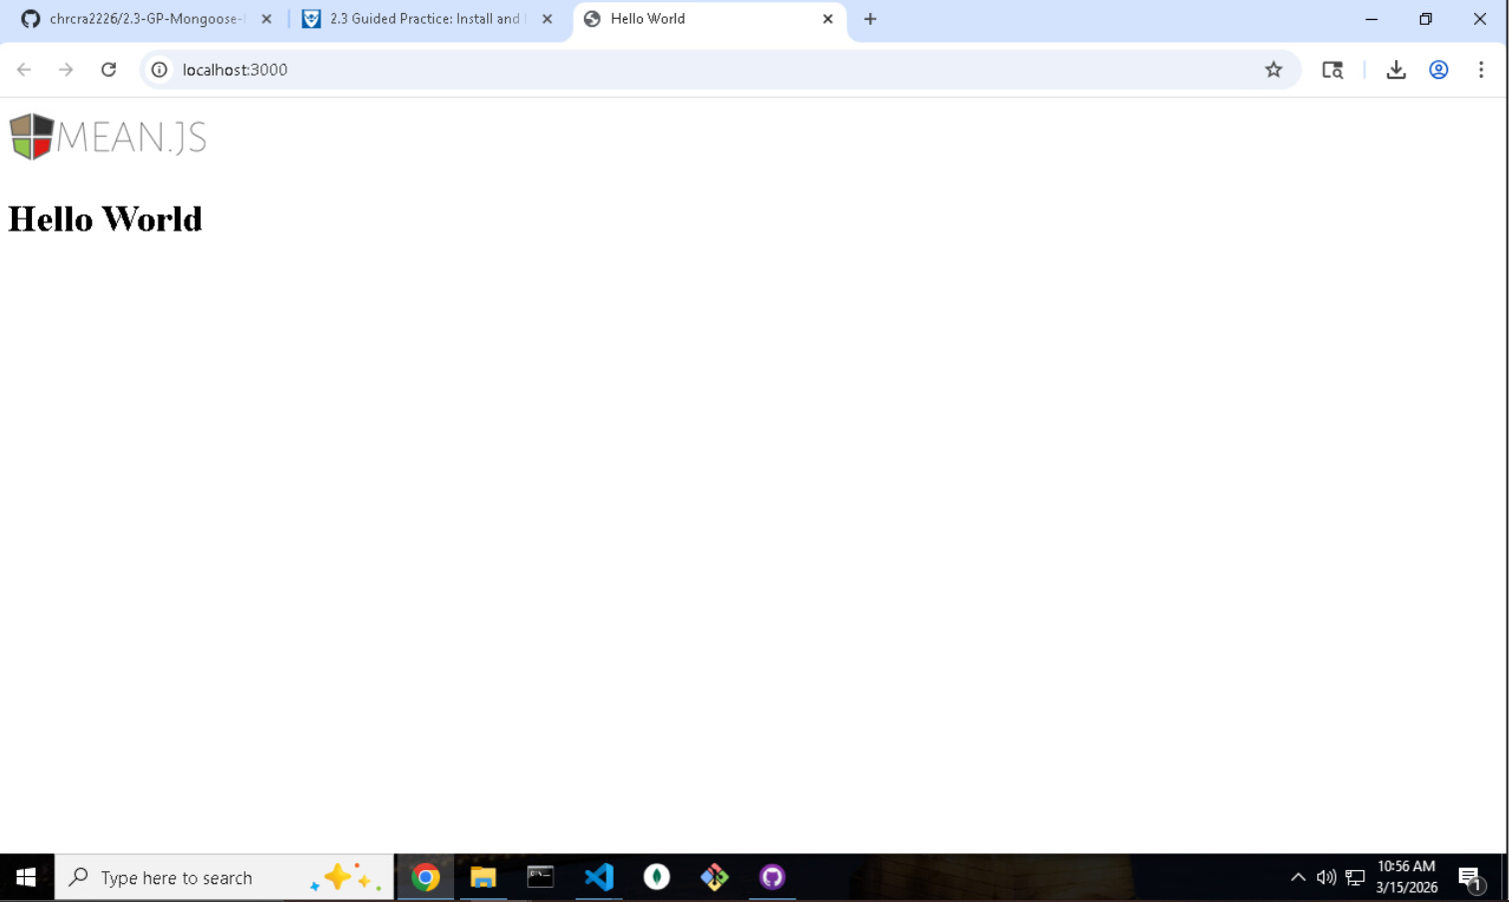
2. Code showing connection with MongoDB:
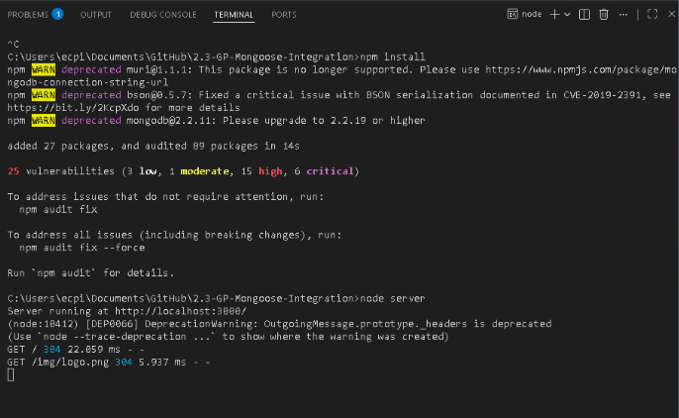
3. Git Bash code ran:
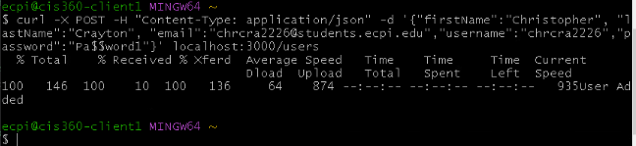
4. Communication with VS Code:
